**AIM:**

**DATE: 18-March-2021**

**Roll no.:18BCE186**

**Name: Prem Desai**

**Course: LAMP TECHNOLOGY**

**2CSDE69**

**Practical No.:05**

**(A) Derive a class square from class Rectangle. Create one more class circle. Create an interface with only one method called area(). Implement this interface in all the classes. Include appropriate data members and constructors in all classes. Write a program to accept details of a square, circle and rectangle and display the area**

**(B) A super class Record has been defined to store the names and ranks of 50 students. Define a sub class Rank to find the highest rank along with the name. The details of both classes are given below:**

**Class name : Record**

**Data Members / instance variables:**

**• name[ ] : to store the names of students**

**• rnk[ ] : to store the ranks of students**

**Member functions:**

**• Record( ) : constructor to initialize data members**

**• void readvalues( ) : to store names and ranks**

**• void display( ) : displays the names and the corresponding ranks**

**Class name : Rank**

**Data Members / instance variables:**

**• index : integer to store the index of the topmost rank**

**Member functions**

**• Rank( ) : constructor to invoke the base class constructor and to initialize index to 0.**

**• void highest( ) : finds the index location of the topmost rank and stores it in index without sorting the array 6**

**• void display( ) : displays the name and ranks along with the name having the topmost rank.**

**Specify the class Record giving details of the constructor( ), void readvalues( ), void display( ). Using the concept of inheritance,** **specify the class Rank giving details of constructor( ),void highest( ) and void display().**

**Methodology followed:**

**(A)**

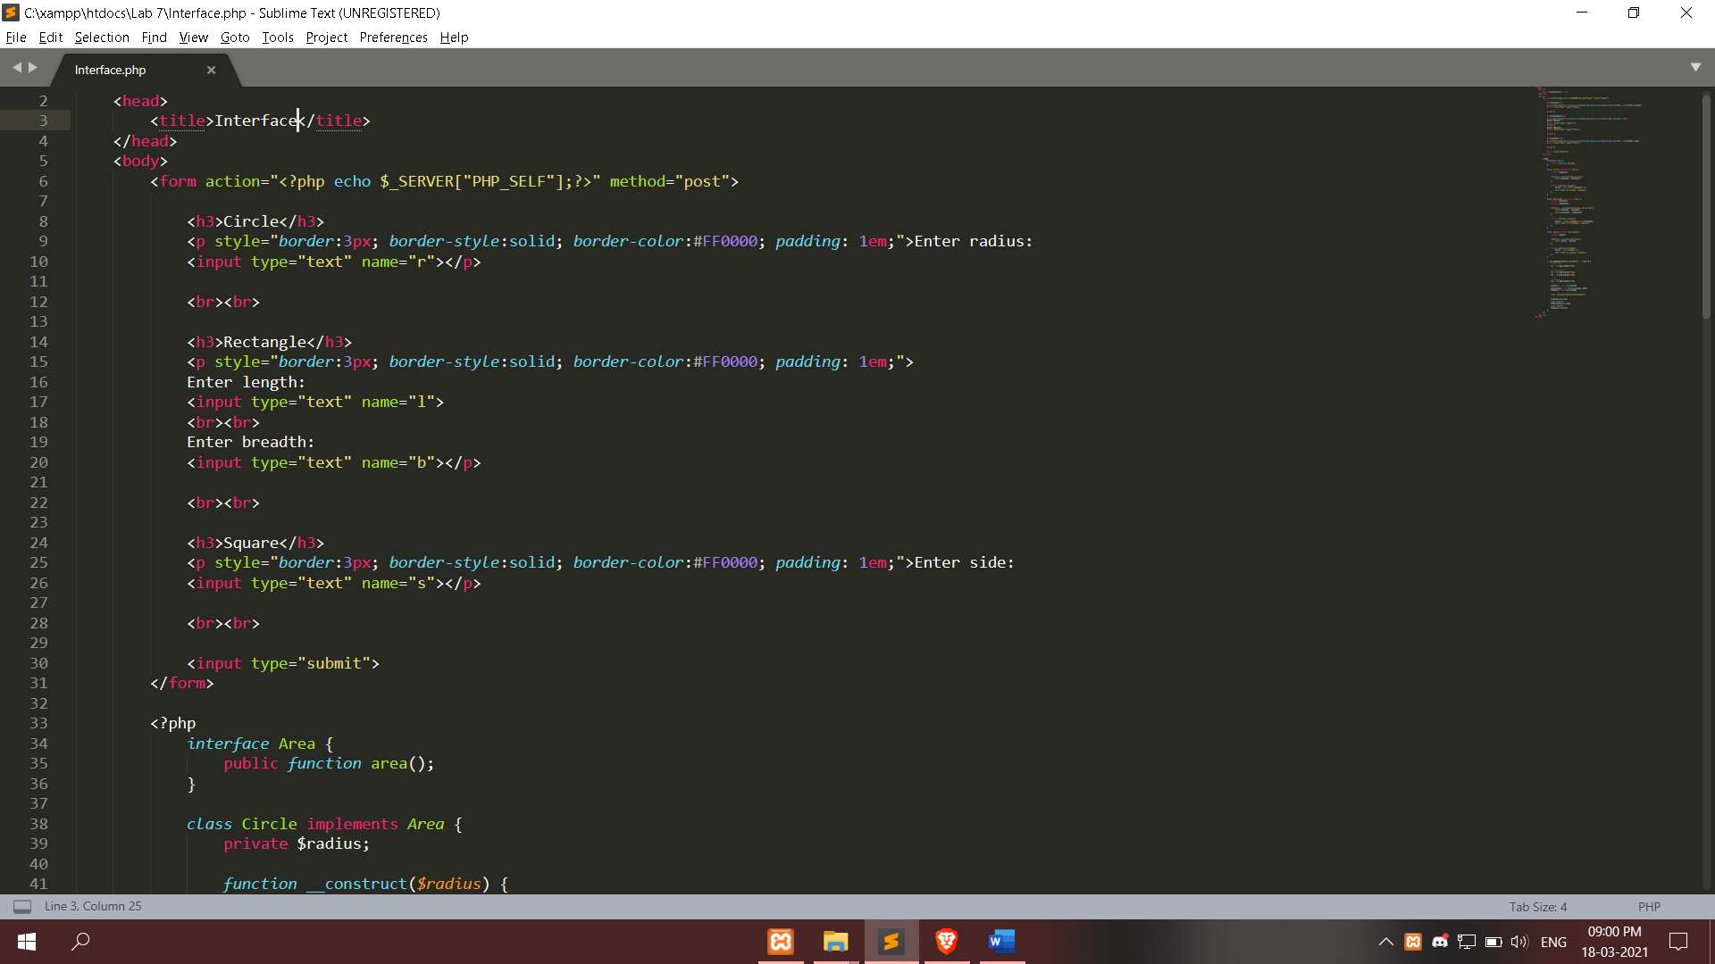

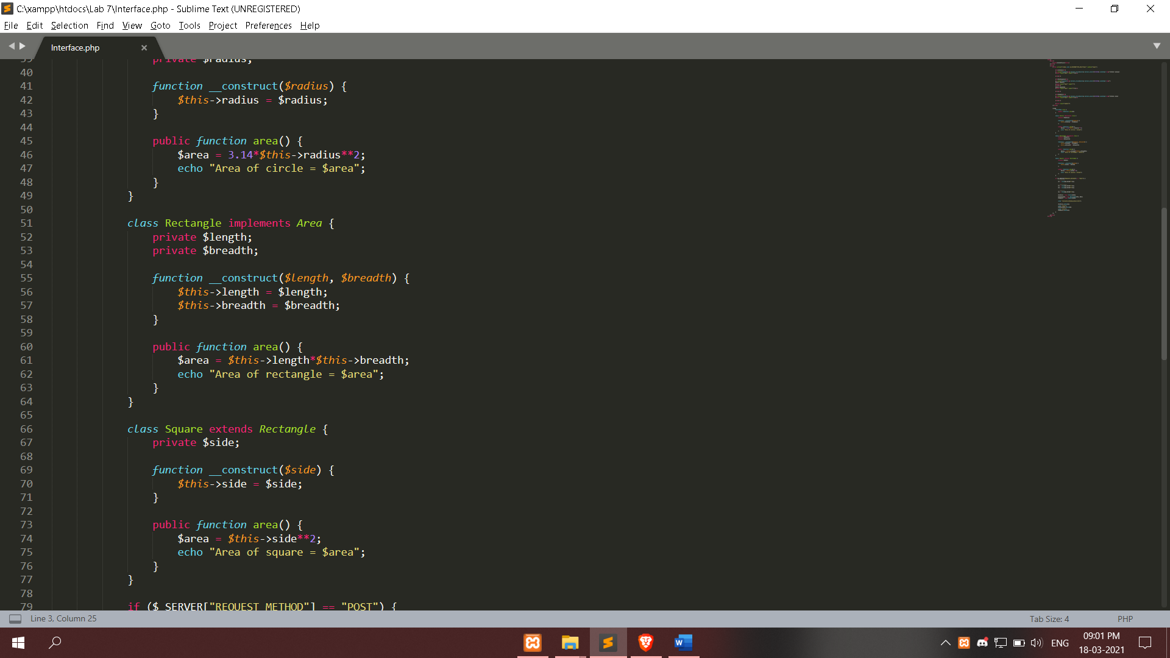

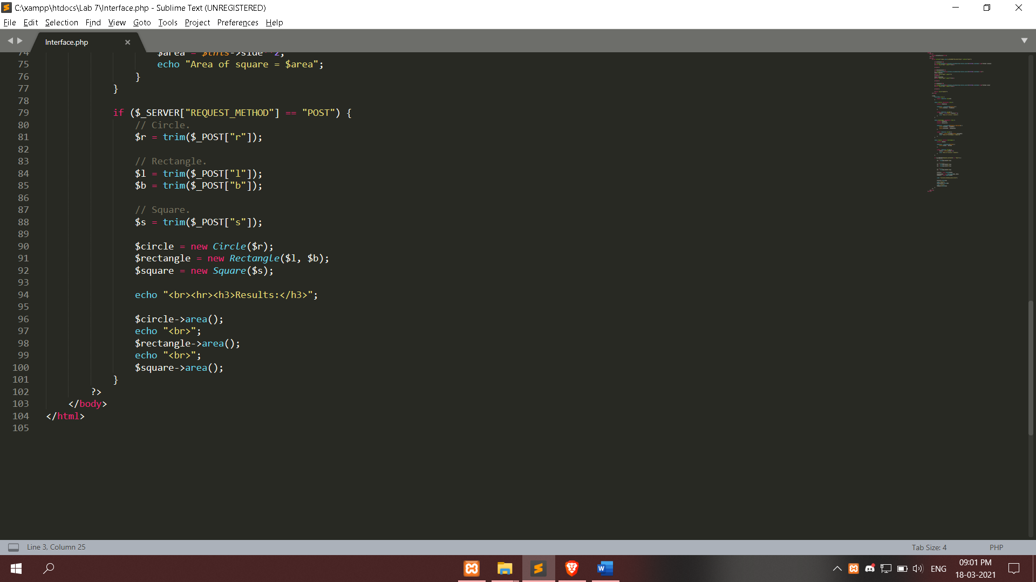

**(B)**

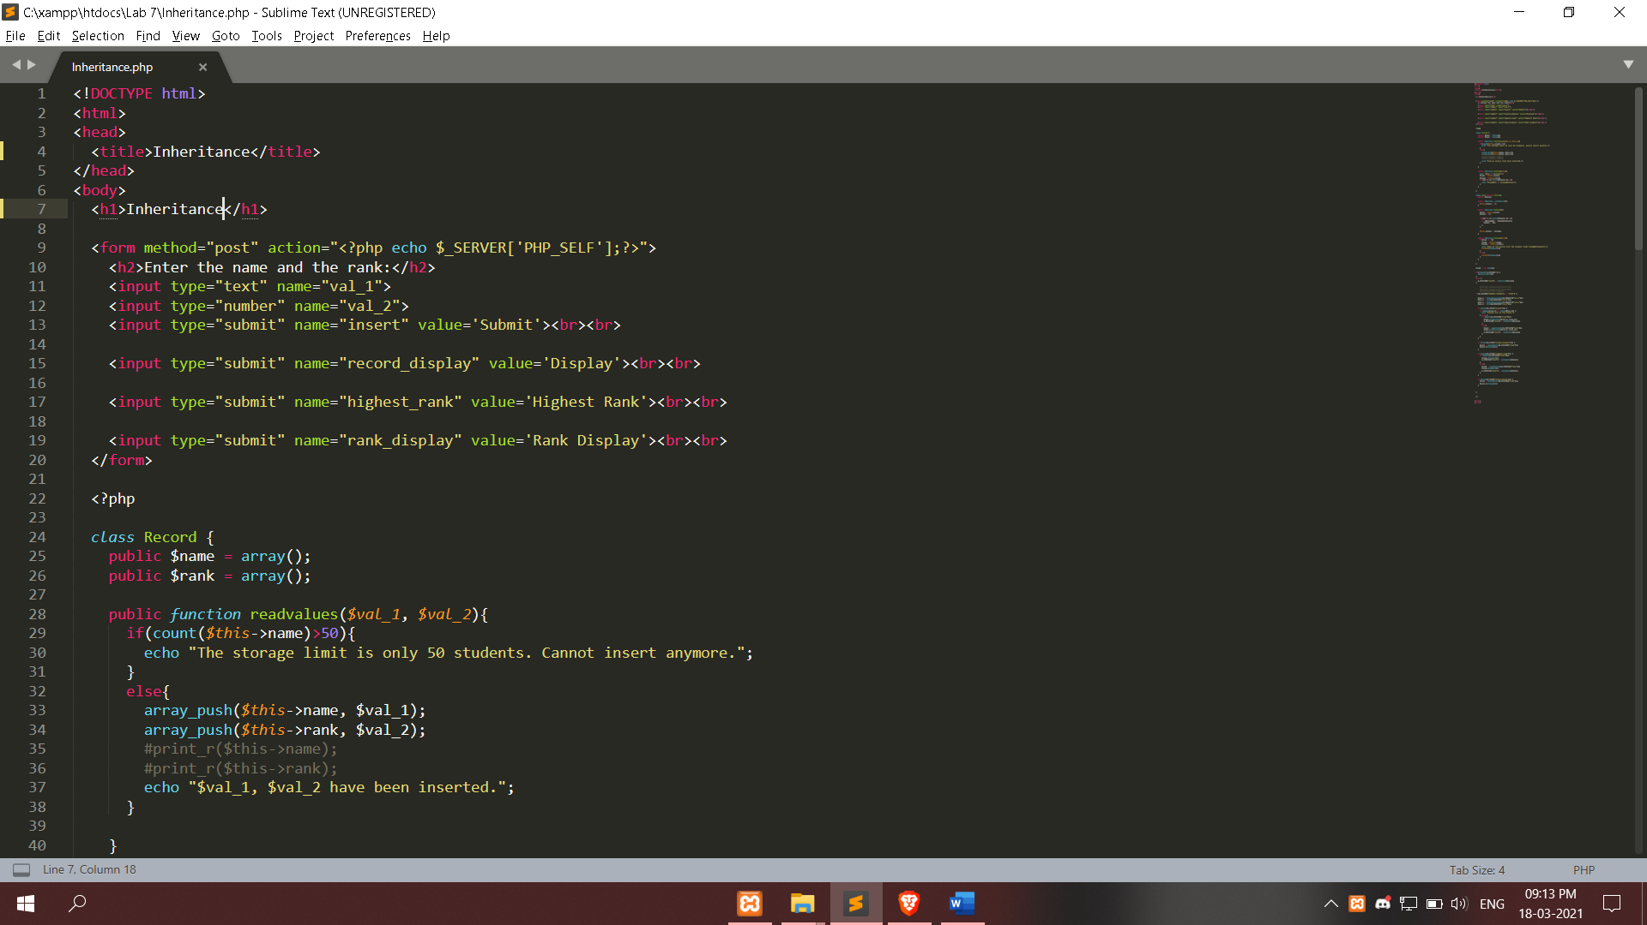

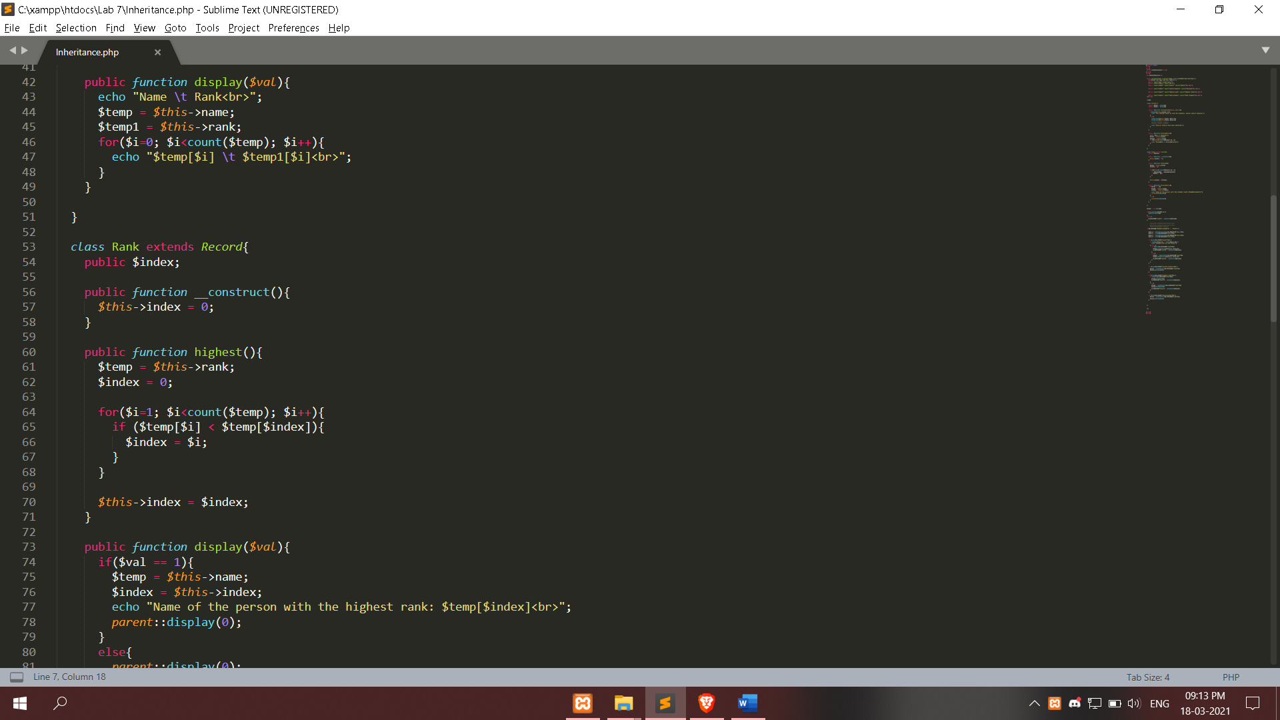

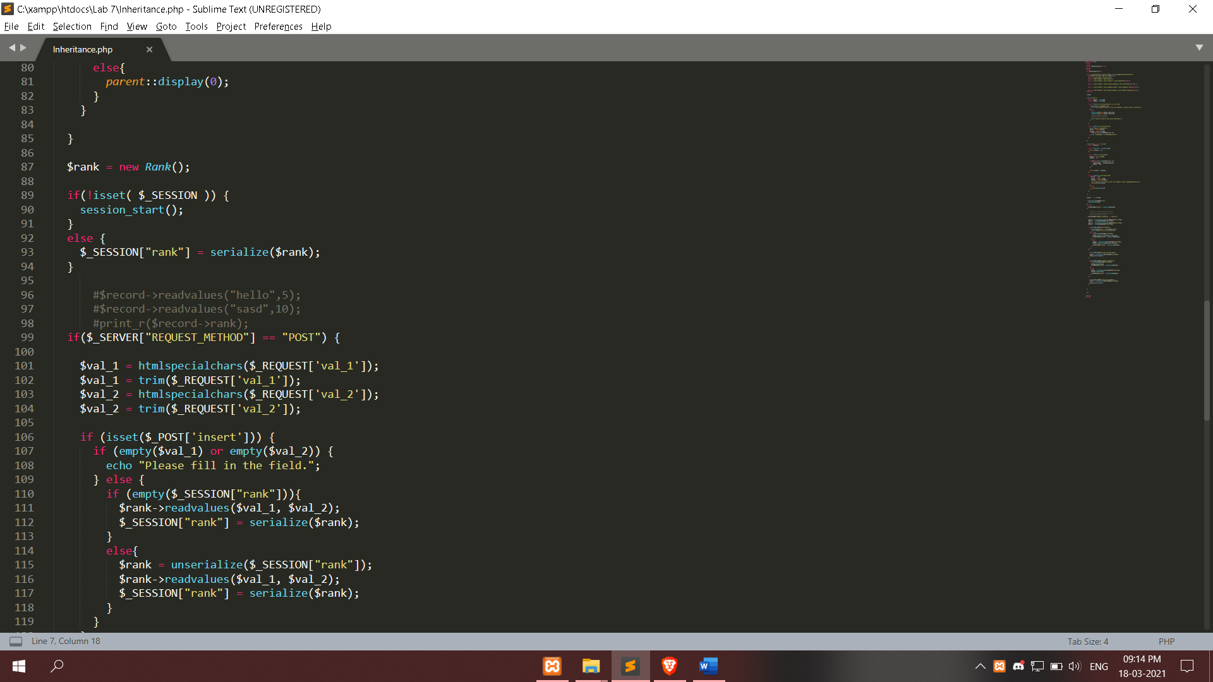

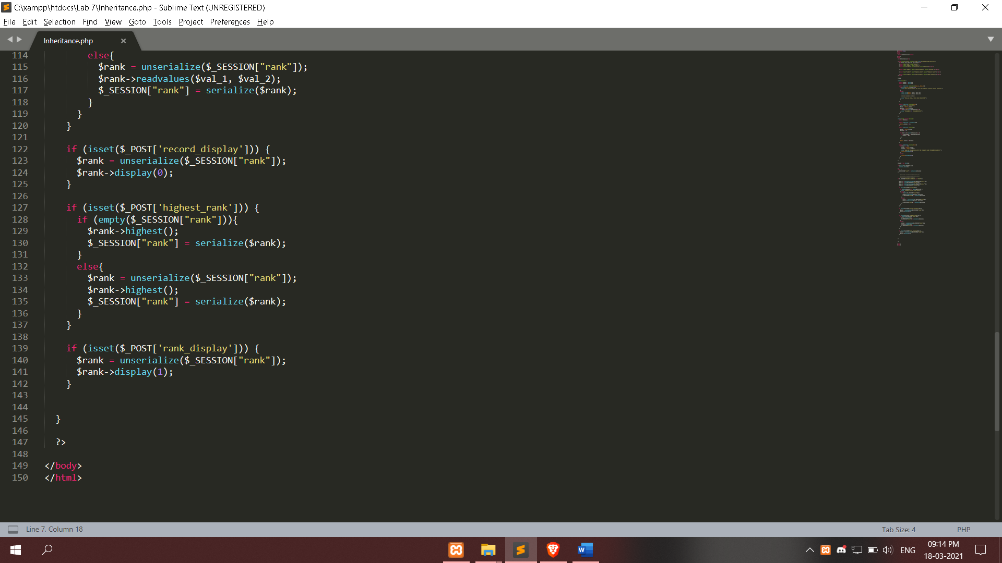

**Input / Output:**

**(A)**

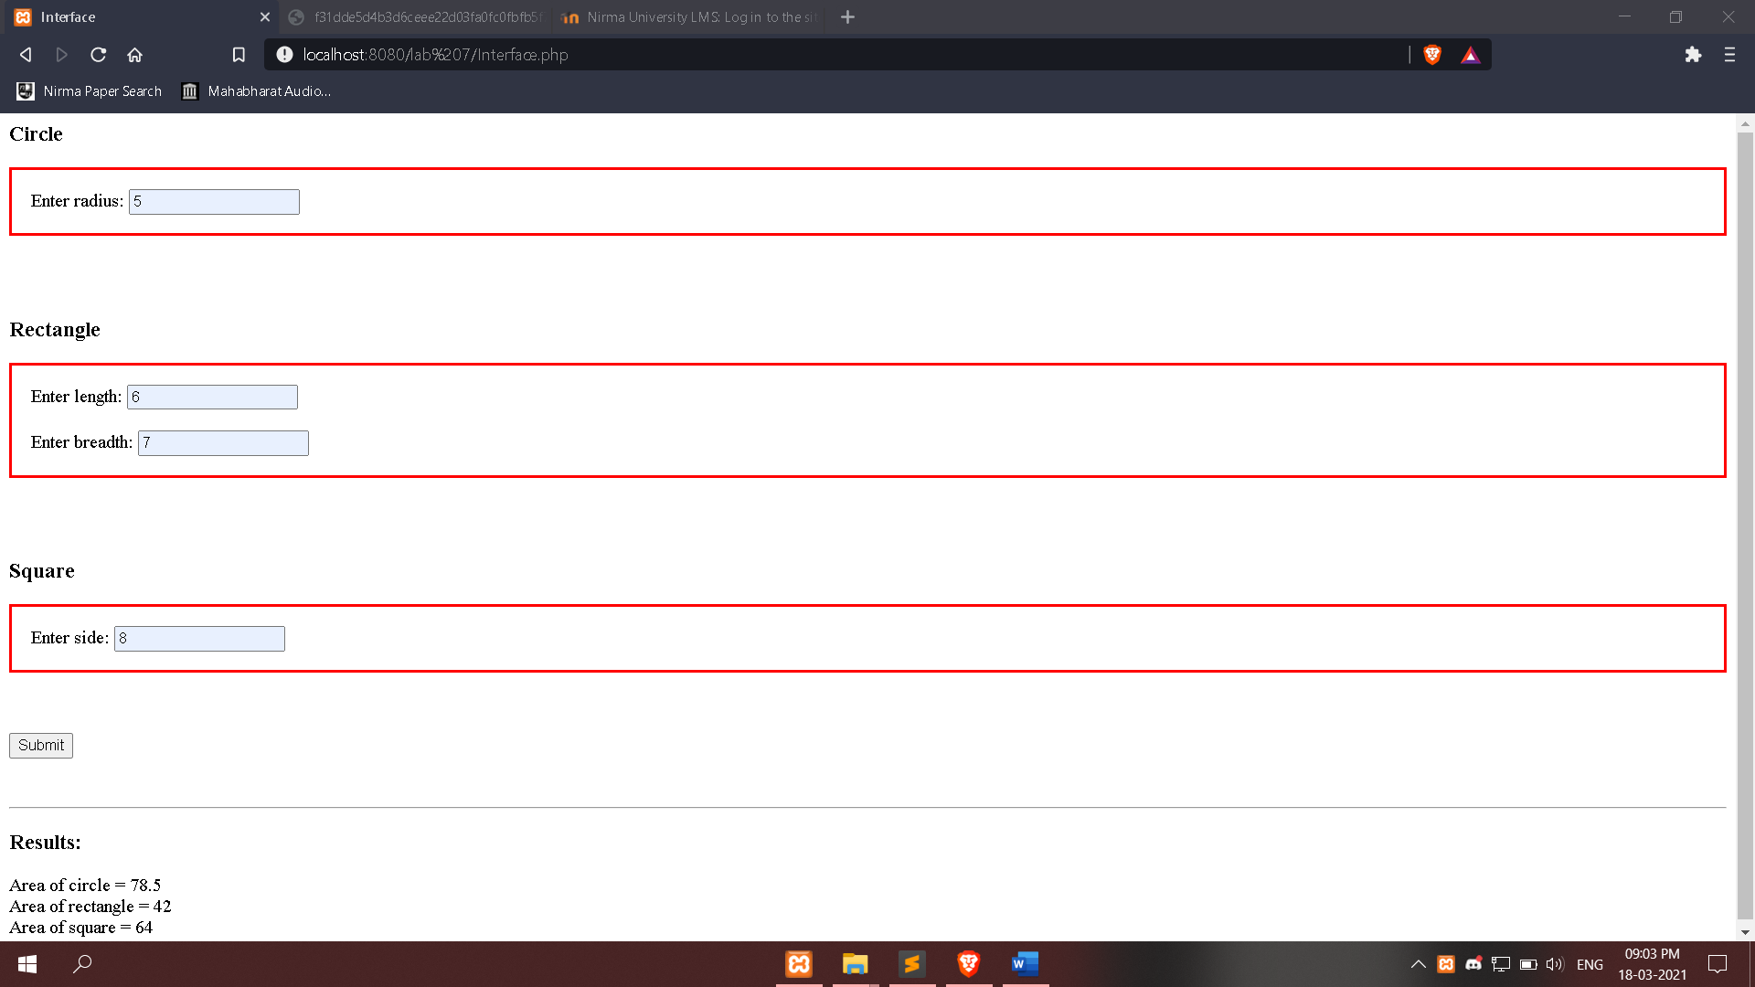

**(B)**

